SCHOOL NAME: Perth-Andover Middle School

Parent School Support Committee:

Date: January 10th, 2023 Time: 6 pm – 7 pm
Location: PAMS – Ms. Sieben’s room

School/DEC Representation:
Claudine Dionne, Principal,
Tanya Adams, DEC

PSSC Members Present:
Tanya Murchison
Krista Christophersen
Joe Bailey
Beth Boyd
Chrissy Young
Christy Dingee

PSSC Members Absent:
Sarah Martin
Jessica Post
Tara Cyr

Call to Order: Chrissy called the meeting to order at 6:00pm.

Approval of the Agenda: Tanya moved, and Beth seconded the approval of tonight’s agenda.

Approval of the Minutes from Previous Meetings (June 14th, 2022, and October 24th, 2022): Motion to approve brought forth by Chrissy. Christy voted to approve the minutes from June 14th, seconded by Beth. All approved however Joe Bailey did not vote as he was not at the June meeting. Beth motioned to approve the October minutes, and this was seconded by Tanya. All minutes approved.
Business Arising from the Minutes:
Business Related to the First Meeting:
- Results from the virtual PSSC election – position for this year are as follows: Chrissy Young Chairperson, Joe Bailey, Vice Chairperson, Christy Dingee, Secretary.
- Cell phone policy update: very successful – little resistance from students. Parents supportive. Staff pleased to see more engaged students during free time.
- Poinsettia fundraiser: 200 plants sold with a $750 profit – this is less then in past. School dances continue to be a good revenue source.
Principal’s Report:
- Staffing: Sherry Hansen is the temporary custodian – there is currently an open position looking to be filled.

- Mrs. Perley currently on medical leave – hopeful for her return. Wolastoqey students will be receiving extra math and LA support until a replacement is found.

- Student increase of two grade 6 students. See below for specific class breakdown.

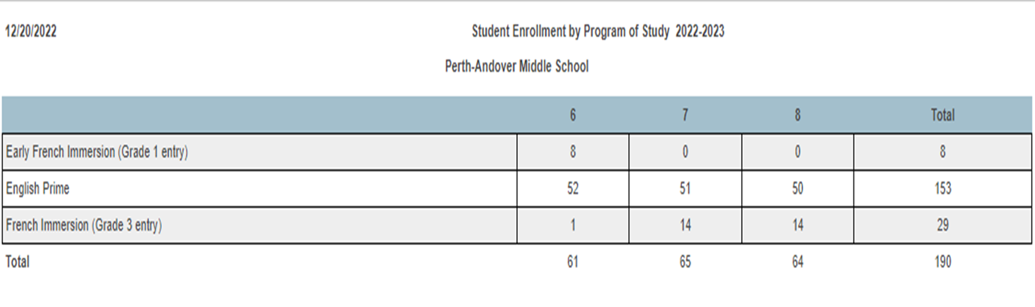

- School Improvement Plan – the goal and several strategies were reviewed.
Upgrade to concreate outside, computer lab upgrade, equipment for physical education classes in addiction to science equipment and a large screen for the gym to replace the inflatable one. Monies allocated for these improvements will be spent immediately as it will be withdrawn if items are not in the possession of the school by March.
Goal – At PAMS, we will demonstrate a positive change in the sense of safety felt by students and staff. We will focus on the physical safety measured by the teacher perception/student survey.
Indicators of success
Bullying / Language
- At PAMS, there will be a decrease of inappropriate language.
- At PAMS, there will be fewer disruptions in the classroom.
- At PAMS, students will feel safe.

Engagement
- At PAMS, attendance will improve.
    - Increase in opportunities for parent engagement at PAMS.

Discussed attendance and how to improve. Currently staff are calling parents/guardians to follow up on absences and plan to approve attendance. Club day will be resuming on the 18th of January – club day is a large draw and attendance improves on these days. January 2023 will see attendance incentives – possibly looking at some sort of reward system with exceptions allowed for medical, busses not running or weather.

Activities being created and promoted to increase parental involvement and awareness at PAMS. Activities to date have been successful and include back to school open house, bingo nights (45 attended in November, 65 attended in December). Upcoming events are February fun night, spring fling and summer kick off. Monthly newsletter also being utilized.

- PBIS –The positive behavior Support incubator program was explained. The school will receive 20 release days /year for 3 years to embed PBIS in the school along with $1000.
      - PAMS will focus on community involvement with the school and school wide expectations and routine for 2022-23.

January and February PBIS will focus on Achievement (getting to class on time and being prepared for class, having work completed and having a growth mindset). Students will be recognized for this behaviour at the January/February assembly.

- Special events in Nov/Dec saw a 5-week bullying awareness campaign completed. $500 ++ donated to the local food bank; the continuation of the free breakfast program along with a free Christmas lunch and $25 Superstore cards being sent to all families. This year has also seen the return of the Principal’s List. Upcoming lunch to celebrate this achievement will be held Jan 12th.

Students enjoyed the robotics seminar put on by Elephant Thoughts along with French Friday’s.
New Business:

- Progress reports will be out week of Feb 6th,
- Report cards following April 12th.
- Youth check -in and annual provincial survey results will be shared in the spring.
- MAAD will be doing a presentation on cannabis in March.

Meeting Adjourned at 7:00 pm
Date of Next Meeting: Claudine will send out the date of the next meeting, the minutes, and PowerPoint in advance.
Motion to Adjourn: Tanya motioned to adjourn.

